

ASSET VERIFICATION AND RECORDING TOOL KIT


Plot 31, Bukoto Street
P.O Box 7657, Kampala, Uganda
+256 (0) 39 2000216/0772525235
email: cpa@cpa.ug

www.cpa.com

August to September 2026

VERIFICATION DETAILS

NAME OF THE REGION: | GREATER MASAKA
SUB-REGION:
Name of Local Government | LYANTONDE DISTRICT
VERIFIER PARTICULARS
Full name | NANTUMBWE PENINAH
Contact/ email and Telephone | 0704321431
Supervisor/ Sub team leader
Name | KALYOWA LAWRENCE
Contact | 0774106047
Date of submission

HEALTH CENTRES
INFORMANT INTERVIEW/DISCUSSION GUIDE (INCHARGE OR RESPONSIBLE PERSON)

Name of Health Centre: LYAKAJJUKA HEALTH CENTRE III

1a | Does the Facility have a record of all assets provided under UgIFT.  (Obtain a record and verify if it has the costs and numbers supplied | Yes
1b | If Not ask how many were supplied and when.

2 | How does this facility Maintain (repair/service/replace) the assets provided under Ugift

They received funds

3 | Does the facility take regular record about functionality/ or breakdown of the assets provided? | Yes

4 | How has the UgIFT support helped in service delivery in the area, any issues, challenges and any recommendations for better program implementation.

Challenges
- They lack profession in using these equipments
- Lack of staffs
- Some equipments are incomplete

PROCEED TO VERIFICATION AFTER THIS DISCUSSION

Recommendations

- Teaching them how to use these equipments

- Getting more staffs
Health centre checklist

NAME OF LG; LYANTONDE DISTRICT NAME OF HEALTH FACILITY: LYAKAJJUKA HEALTH CENTRE III

Equipment/ Item | Department | Asset Number | Item  Description | Life in Months | Tag Number ( engrave no.) | Date Of Purchase | Date Placed In Service | Recoverable cost | Cost | Acc Dep Cost | Net Book Value | Ytd Deprn | Equipment status | Remarks
B.P. Machine, Digital | O.P.D |  | TRANSTEK  TMB-2088-C | 1 year | LYK/0395 | 28th/7/2025 | Aug 2025 |  |  |  |  |  | Non functional | They got 2 but 2 of them are non functional
B.P. Machine (Aneroid wall mounted) | Maternity |  |  | 1 year |  | 28/7/2025 | Aug 2025 |  |  |  |  |  | Good | Functional
Autoclave 20 Liters.,Duo Operated | Maternity |  | 02 | 1 year | 30 months | 28/7/2025 | Aug 2025 |  |  |  |  |  | Functional | Functional
Bowl, Kick | Maternity |  | 01 | 1 year |  | 28/7/2025 | Aug 2025 |  |  |  |  |  | Functional | Functional
Bowl Stand | Maternity |  | 02 | 2 years |  | 28/7/2025 | Aug 2025 |  |  |  |  |  | Functional | Functional
Counting chamber Neubauer- Improved |  |  | 02 | 2 years |  | 28/7/2025 | Aug 2025 |  |  |  |  |  | incomplete | Staining soln was not received
Cupboard Steel, Lockable | OPD |  | 02 | 2 years | LYW0395/Y25/070/034 | 28/7/2025 | Aug 2025 |  |  |  |  |  | Functional | Functional
Drip Stand | Ward |  | 08 | 1 year |  | 28/7/2025 | Aug 2025 |  |  |  |  |  | Functional | Not engraved
ESR Stand | LAB |  | 01 |  |  | 11/4/2023 | 20/8/ 2025 |  |  |  |  |  | Good | Functional
Examination Couch | OPD/IPD |  | 02 |  | /050 | 11/4/2023 | 20/8/2025 |  |  |  |  |  | Good | Functional
Examination light,LED | MCH |  | 02 |  |  | 11/4/2023 | 20/8/ 2025 |  |  |  |  |  | Good | Functional
Glucometer | LAB |  | 02 |  |  | 11/4/2023 | 20/8/ 2025 |  |  |  |  |  | Good | Functional
Haemoglobin Meter, Digital | LAB |  | 02 |  |  | 11/4/2023 | 20/8/ 2025 |  |  |  |  |  | Good | Functional
Height Meter | OPD |  | 01 |  |  | 11/4/2023 | 20/8/ 2025 |  |  |  |  |  | Good | Functional
Instrument Trolley | OPD |  | 02 |  |  | 11/4/2023 | 20/8/ 2025 |  |  |  |  |  | Good | Functional
Microscope Binocular | LAB |  | 01 |  | 051436CH | 11/4/2023 | 20/8/ 2025 |  |  |  |  |  | Good | Not Engraved
Otoscope | OPD |  | 01 |  |  | 11/4/2023 | 20/8/ 2025 |  |  |  |  |  | Functional | Not engraved
Patient Screen | MCH IPD |  | 04 |  |  | 11/4/2023 | 20/8/2025 |  |  |  |  |  | Good | Functional
Patient Trolley | OPD |  | 01 |  |  | 11/4/2023 | 20/8/ 2025 |  |  |  |  |  | good | Functional
Refrigerator, Basic | LAB |  | 01 |  | /060 | 11/4/2023 | 20/8/ 2025 |  |  |  |  |  | Good | Functional
Stethoscope | OPD |  | 04 |  |  | 11/4/2023 | 20/8/ 2025 |  |  |  |  |  | Good | Functional
Stop Watch | MCH/OPD |  | 02 |  |  | 11/4/2023 | 20/8/ 2025 |  |  |  |  |  | Good | Functional
Stretcher | OPD |  | 01
Stove, Gas | LAB |  | 01 |  | /135 | 11/4/2023 | 20/8/ 2025 |  |  |  |  |  | Incomplete | The set is incomplete
Weighing Scale with Height Meter, Adult | MCH & OPD |  | 02 |  | LYW/039/725/125 | 11/4/2023 | 20/8/2025 |  |  |  |  |  | Good | Functional
Weighing Scale, Infant | MCH/OPD |  | 02 |  | 136
Weighing Scale, Toddler | MCH |  | 02 |  | LYK/0395 | 11/4/2023 | 20/8/2025 |  |  |  |  |  | Good | Functional
Wheel Chair | MCH & OPD |  | 02 |  | /096 | 11/4/2023 | 20/8/2025 |  |  |  |  |  | Good | functional
Audio Visual Equipment
Medical Waste Bin | MCH, OPD, IPD |  | 06 |  |  | 14/4/23 | 20/8/2025 |  |  |  |  |  | Functional | 1 bin worn out and put in store
Wall Clock |  |  | 04 |  |  | 11/4/2023 | 20/8/2025 |  |  |  |  |  | Good | Not engraved
Diagnostic Equipment Set for MCH | MCH |  | 02 |  |  | 11/4/2023 | 20/8/2025 |  |  |  |  |  | Functional | Functional
Diagnostic Equipment Set for OPD | OPD |  | 02 |  |  | 11/4/2023 | 20/8/2025 |  |  |  |  |  | Functional | Functional
Glassware Set, Laboratory, Basic | LAB |  | 02 |  |  | 11/4/2023 | 20/8/2025 |  |  |  |  |  | Good | Functional
Hollow Ware Set, Treatment | Maternity |  | 03 |  | 1080 | 11/4/2023 | 20/8/2023 |  |  |  |  |  | Good | Functional
Instrument Set, Dressing | OPD |  | 02 |  | 1075 | 11/4/2023 | 20/8/2025 |  |  |  |  |  | Good | Functional
Instrument Set, Basic ENT | OPD
Instrument Set, Suture | OPD |  | 02 |  |  | 11/4/2023 | 20/8/2025 |  |  |  |  |  | Functional | Functional
Pulse Oximeter, Hand held | MCH & OPD |  | 02 |  |  | 11/4/2023 | 20/8/2025 |  |  |  |  |  | Functional | Functional
Bed, Adult Patient with Mattress | IPD |  | 10 |  | LYK/0395/Y25/005 | 11/4/2023 | 20/8/2025 |  |  |  |  |  | Functional | 8 were redistributed by the district.
Bed, Pediatric Patient, With Mattress | IPD |  | 06 |  | LYK/0395/725/062 | 11/4/2023 | 20/8/2025 |  |  |  |  |  | Good | Functional
Bedside Locker | IPD |  | 01 |  |  | 11/4/2023 | 20/8/2025 |  |  |  |  |  | Good | Functional
Cupboard, Instrument | MCH |  | 01 |  |  | 11/4/2023 | 20/8/2025 |  |  |  |  |  | Good | Functional
Delivery Bed, Hydraulic Manual | Maternity |  | 01 |  | 0002 | 11/4/2023 | 20/8/2025 |  |  |  |  |  | Good | Functional
Oxygen Therapy Apparatus, Mininum 45L cylinder | IPD  Maternity |  | 02 |  | 079/098 | 11/4/2023 | 20/8/2025 |  |  |  |  |  | Good | Functional
Resuscitator Manual, Infant, with all Mask sizes | MCH |  | 02 |  |  | 11/4/2023 | 20/8/2025 |  |  |  |  |  | Good | Functional
Resuscitator Manual, Adult, with all mask sizes | IPD/OPD |  |  |  | 1075 | 11/4/2023 | 20/8/2025 |  |  |  |  |  | Good | Functional
Suction Apparatus, (Electric) | Maternity |  | 01 |  | /100 | 11/4/2023 | 20/8/2025 |  |  |  |  |  | Good | Functional
Nebulizer, Ultrasonic | OPD |  | 02 |  | /0395 | 11/4/2023 | 20/8/2025 |  |  |  |  |  | Good | Functional
Oxygen Concentrator, Duo Flow | Maternity & store |  | 04 |  | /103  /102  /101  /104 | 11/4/2023 | 20/8/2025 |  |  |  |  |  | Good | Functional
Bench |  |  | 04 |  |  | 11/4/2023 | 20/8/2025 |  |  |  |  |  |  | Not engraved
Disinfection Buckets |  |  | 06 |  | LYK/039/125/122  121  120  119  118 | 11/4/2023 | 20/8/2025 |  |  |  |  |  | Functional | Functional
Baby Cot | Maternity |  | 05 | 4 months |  | 11/4/2023 | 20/8/2025 |  |  |  |  |  | Functional | Functional
Diagnostic Equipment Set for Ward | Maternity |  | 01 | 40 months |  | 11/4/2023 | 20/8/2025 |  |  |  |  |  | Functional | Functional
Hollow Ware Set, Ward | Maternity |  | 01 | 30 months |  | 11/4/2023 | 20/8/2025 |  |  |  |  |  | Functional | Functional
Instrument Set, Delivery | Maternity |  | 02 | 30 months | /073  /071 | 11/4/2023 | 20/8/2025 |  |  |  |  |  | Functional | Functional
Instrument Set, Stitch Removing | Maternity |  | 02 | 30 months |  | 11/4/2023 | 20/8/2025 |  |  |  |  |  | Functional | Not engraved
MVA Kit | Maternity |  | 02 | 30 months |  | 11/4/2023 | 20/8/2025 |  |  |  |  |  | Functional | Not engraved
Stool, Laboratory | LAB |  | 01 |  | LYK/0395 | 11/4/2023 | 20/8/2025 |  |  |  |  |  | Functional | Functional
Penguin Sucker | Maternity |  | 03 |  |  | 11/4/2023 | 20/8/2025 |  |  |  |  |  | Good | Functional
Fetoscope, Dopplar | MCH |  | 02 |  |  | 11/4/2023 | 20/8/2025 |  |  |  |  |  | Good | Not engraved
Bubble CPAP | Maternity |  | 02 |  |  | 11/4/2023 | 20/8/2025 |  |  |  |  |  | Good | Not engraved
Centrifuge (Electric) |  |  | 02 |  |  | 11/4/2023 | 20/8/2025 |  |  |  |  |  | Good | Not engraved
Kangaroo Mother Care Chair | MCH |  | 01
Radiant Infant Warmer | MATERNITY |  |  |  | 224091048 | 11/4/2023 | 10/8/2025 |  |  |  |  |  | Good | Functional
Haemoglobin Meter, Sahli
Delivery Bed | MATERNITY |  | 02 | 30 months | Plgyn/06/SN XSKD 2025 | 1/4/2025 | 10/8/2025 |  |  |  |  |  | Functional | Functional
Examination light | Maternity |  |  |  | LYW/039/125/129 | 1/4/2025 | 10/08/2025 |  |  |  |  |  | Functional | functional
Instrument set, ENT Basic for HCIII |  |  |  |  | /-395 |  |  |  |  |  |  |  |  | Ent service not available.
Bag Valve mask (Ambu Bag), Neonatal | MCH |  | 04 |  | /082202402022 | 1/4/2023 | 10/8/2025 |  |  |  |  |  | Good | Functional
Incubator
Office Chair | Office |  | 04 wooden  07 |  | LYK/0395/Y25/028 | 1/4/2023 | 20/08/2025 |  |  |  |  |  | Good | Functional
Desk | Office |  | 03 |  | LYK/0395/725/015 | 01/4/2023 | 20/08/2025 |  |  |  |  |  | GOOD | Functional
Filing Cabinet
Non Residential Buildings | Health |  | It is 1 building for medical |  | Not engraved | 20/9/20 | 2019/20 |  |  |  |  |  | Good | Functional
Residential Buildings | Health |  | It is 1 building with 2 room for staffs |  | Not engraved | 20/9/20 | 2019/20 |  |  |  |  |  | Good | Functional

Reception Ward Toilets Weighing scale
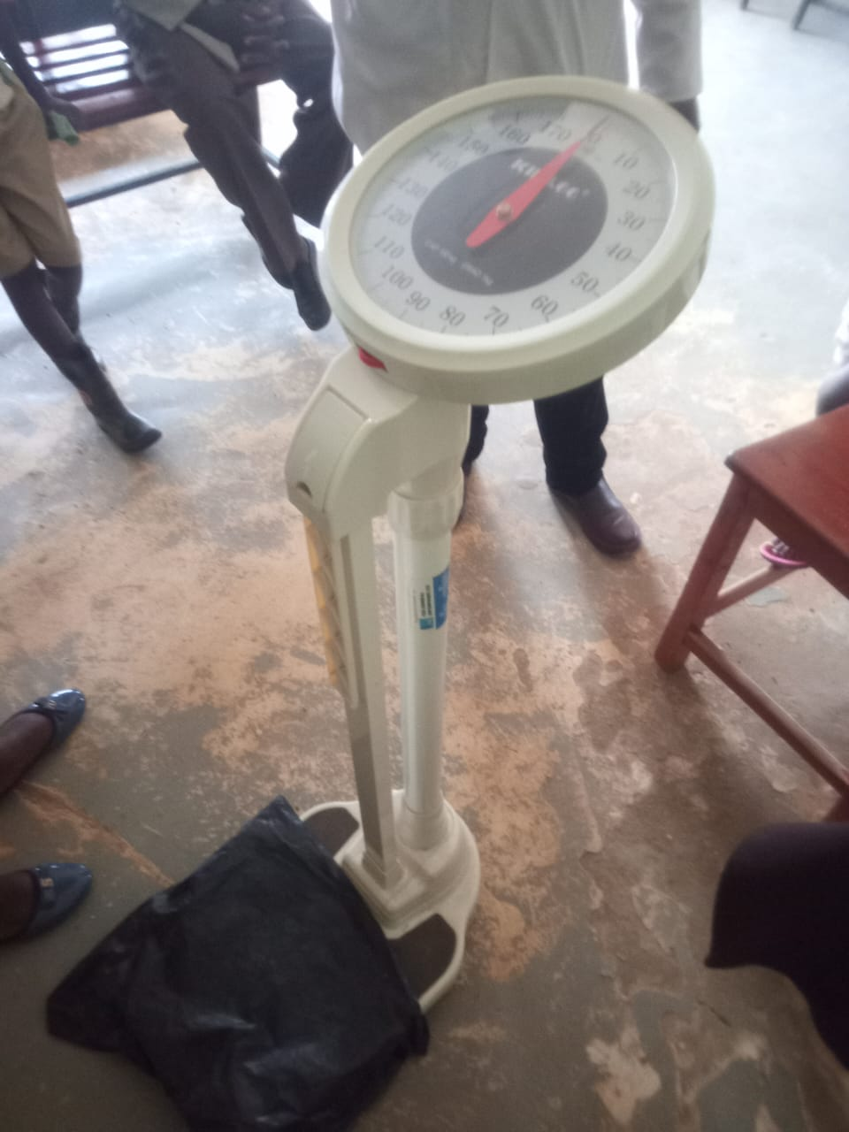
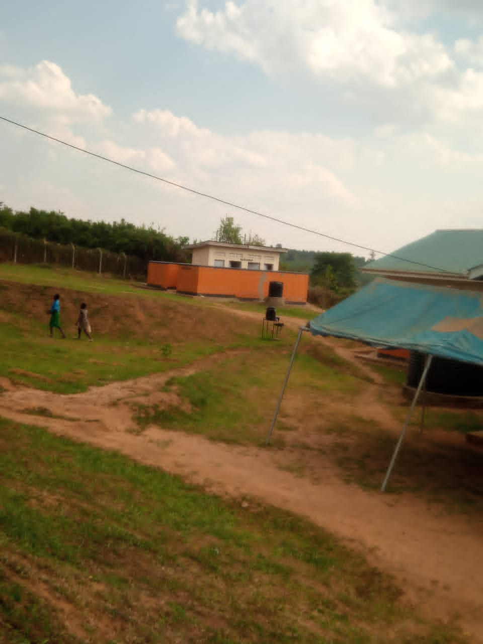
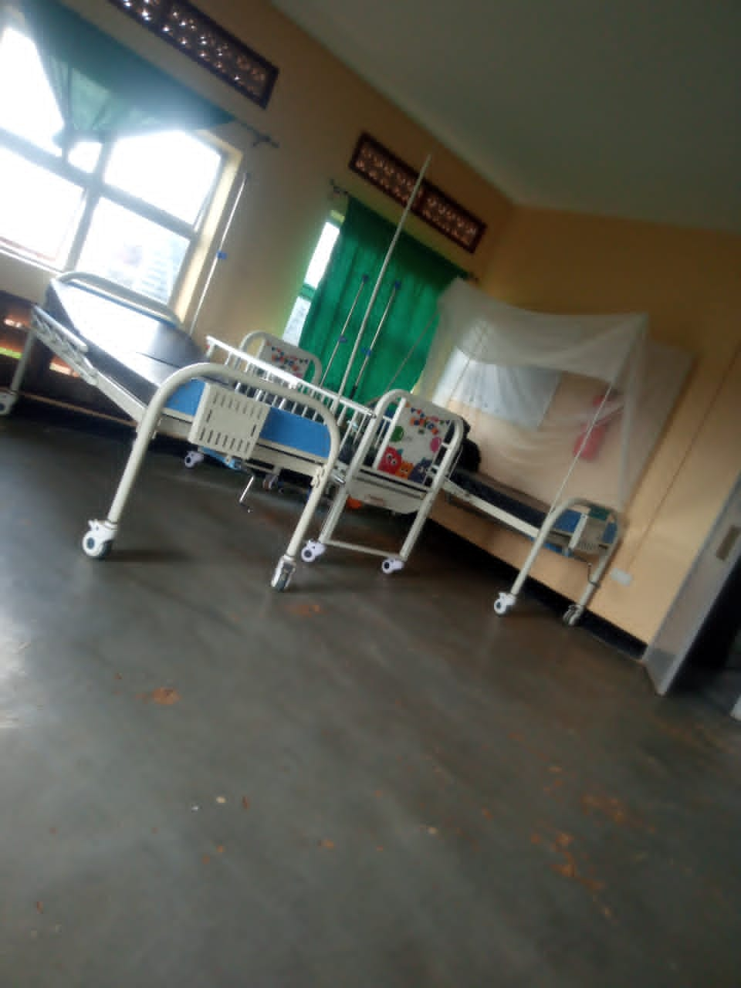
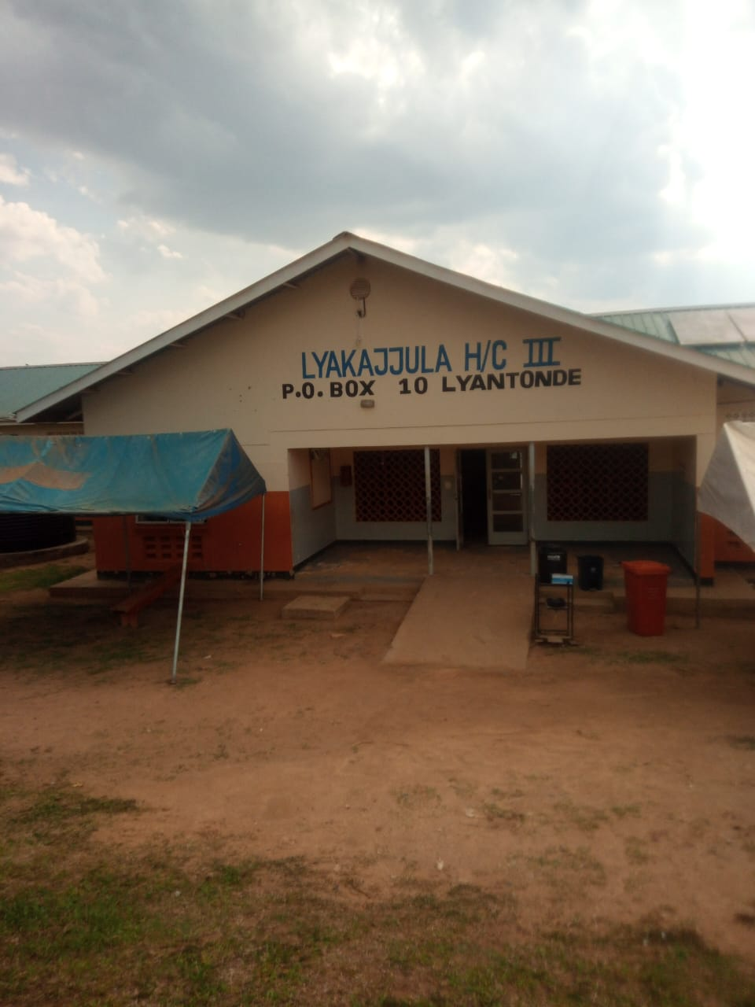
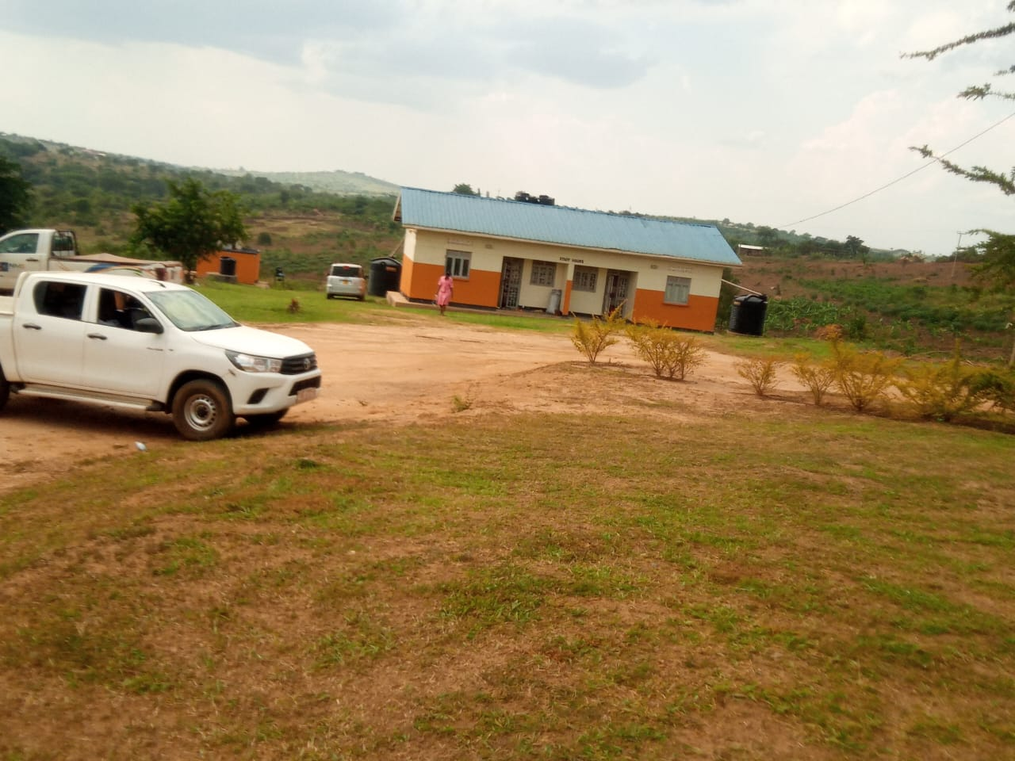
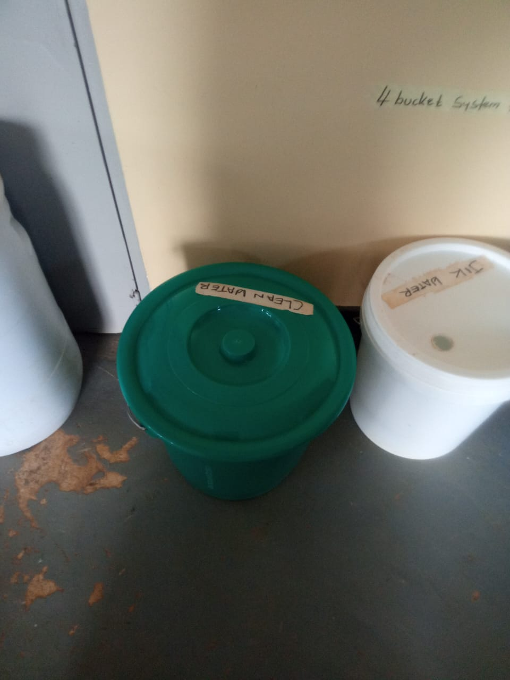
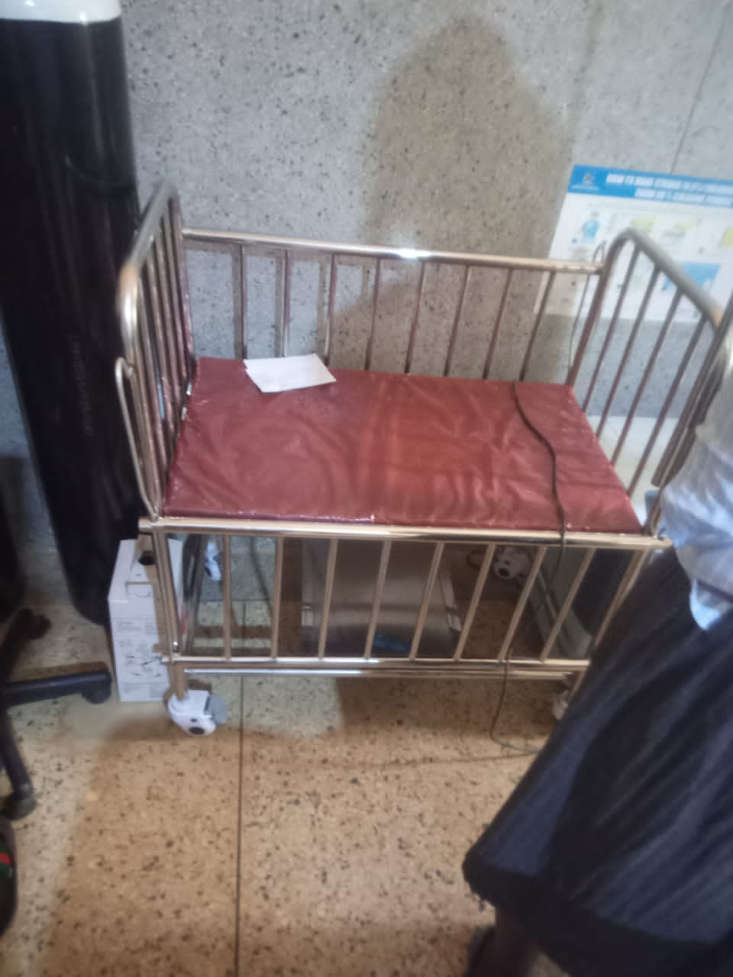

Infant bed Disposed buckets Staff quarters
Infant bed

SCHOOL VERIFICATION CHECKLIST

SCHOOL INTERVIEW/DISCUSSION GUIDE

Name of school: KASAGAMA SEED SECONDARY SCHOOL

1a | Does the Facility have a record of all assets provided under UgIFT.  (Obtain a record and verify if it has the costs and numbers supplied | Yes
1b | If Not ask how many were supplied and when.

2 | How does this facility Maintain (repair/service/replace) the assets provided under Ugift

They get funds from other organizations.

3 | Does the facility take regular record about functionality/ or breakdown of the assets provided?  Nonfunctional/ working, and reasons for non-functionality. | Yes

4 | How has the UgIFT support helped in service delivery in the area, any issues, challenges and any recommendations for better program implementation.

Challenges
- They don’t have enough teacher
- They don’t have enough buildings
- Things they received are not enough
- They received few things and others haven’t reached
- Insufficient funds from the district.

PROCEED TO VERIFICATION AFTER THIS DISCUSSION

SCHOOL FURNITURE
(School Desks, Office chairs, Laboratory stools, Book shelves)

Name of LG: LYANTONDE DISTRICT LOCAL GOVERNMENT Name of SCHOOL: KASAGAMA SECONDARY SCHOOL

Equipment/ Item | Department | Asset Number | Item  Description | Life in Months | Tag Number ( engrave no.) | Date Of Pur | Date Placed In Service | Recoverable cost | Cost | Acc Dep Cost | Net Book Value | Ytd Deprn | Equipment status | Remarks
Desks | Classroom | 102 | Wooden | 91 | Kasagama S.S |  |  |  |  |  |  |  | Fine | Functional
Stools | Lab | 120 | Wooden | 91 | Kasagama S.S |  |  |  |  |  |  |  | Fine | Functional
Tables | Classroom | 21 | Wooden | 91 | Kasagama S.S |  |  |  |  |  |  |  | Fine | Functional
Pinboard | Classroom | 6 | Wooden | 91 | Kasagama S.S |  |  |  |  |  |  |  | Fine | Functional
Open shelves | Classroom | 4 | Wooden | 91 | Kasagama S.S |  |  |  |  |  |  |  | Fine | Functional

ICT ITEMS TO VERIFY
(Desktop Computer, Server Processor, Network Switch 24 Port, Multipurpose Printer, UPS, Projector, Air Conditioners, Server, CCTV Camera)

Name of LG…………………………………………………………………………… Name of SCHOOL………………………….………………………………………

Equipment/ Item | Department | Asset Number | Item  Description | Life in Months | Tag Number ( engrave no.) | Date Of Pur | Date Placed In Service | Recoverable cost | Cost | Acc Dep Cost | Net Book Value | Ytd Deprn | Equipment status | Remarks

BUILDINGS TO VERIFY
(Non- Residential and Residential, Kitchen, Toilets/Pit latrine Water tanks, Fences etc.)

Name of LG: LYANTONDE DISTRICT LOCAL GOVERNMENT Name of SCHOOL: KASAGAMA SEED SECONDARY SCHOOL

Equipment/ Item | Department | Asset Number | Item  Description | Life in Months | Tag Number ( engrave no.) | Date Of Pur | Date Placed In Service | Recoverable cost | Cost | Acc Dep Cost | Net Book Value | Ytd Deprn | Equipment status | Remarks
Classroom | Education |  | There are 3 groups with 2 classrooms | 91 |  |  |  |  |  |  |  |  | Fine | Functional
Multipurpose hall | Education |  | It is 1 block for main hall | 91 |  |  |  |  |  |  |  |  | Fine | Functional
Administration block | Education |  | It is 1 block with office and staffroom | 91 |  |  |  |  |  |  |  |  | Fine | Functional
Computer and library | Education |  | It is 1 block shared with computer and library | 91 |  |  |  |  |  |  |  |  | Fine | Functional
Staff block | Education |  | There are 3 blocks with 2 rooms each | 91 |  |  |  |  |  |  |  |  | Fine | Functional
Science lab | Education |  | It is 1 block shared with all science subjects | 91 |  |  |  |  |  |  |  |  | Fine | Functional
Lay ground | Education |  | It is 1 pitch big and large | 91 |  |  |  |  |  |  |  |  | Fine | Functional
Toilets | Education |  | It has 5 blocks each has 2 rooms on it | 91 |  |  |  |  |  |  |  |  | Fine | Functional
Water tanks | Education |  | They are 3 black in colour; 3000ltrs, 5000ltrs and 10,000ltrs | 91 |  |  |  |  |  |  |  |  | Fine | Functional

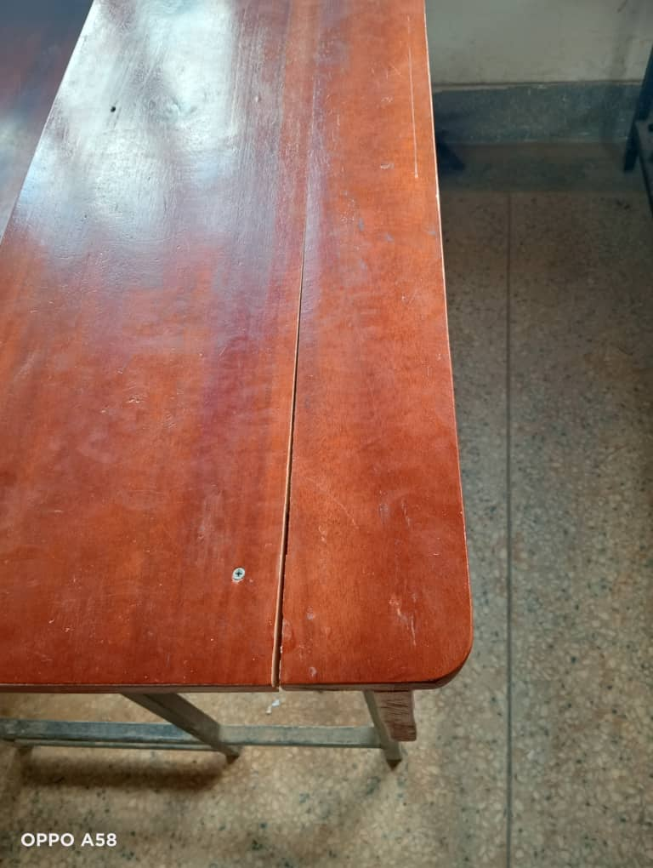
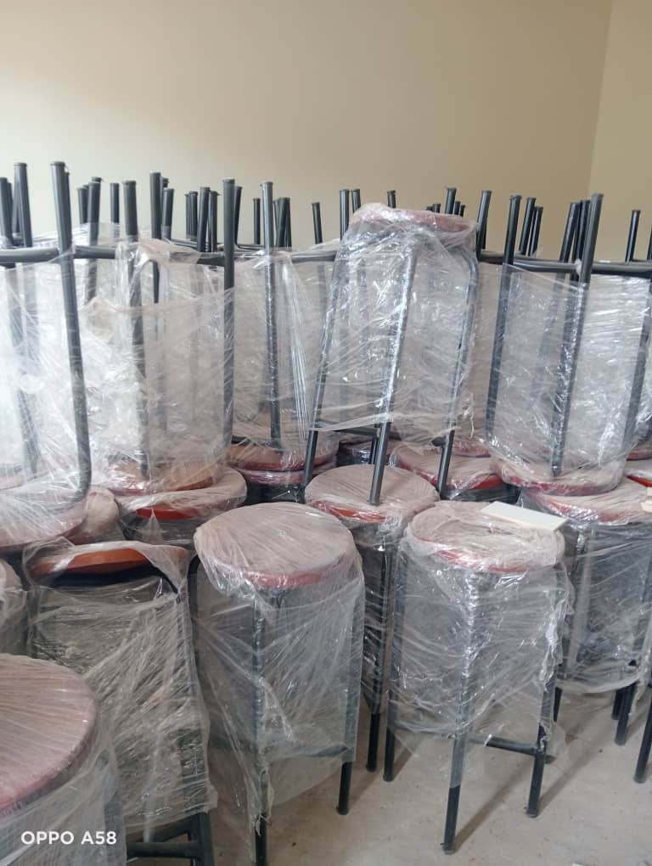

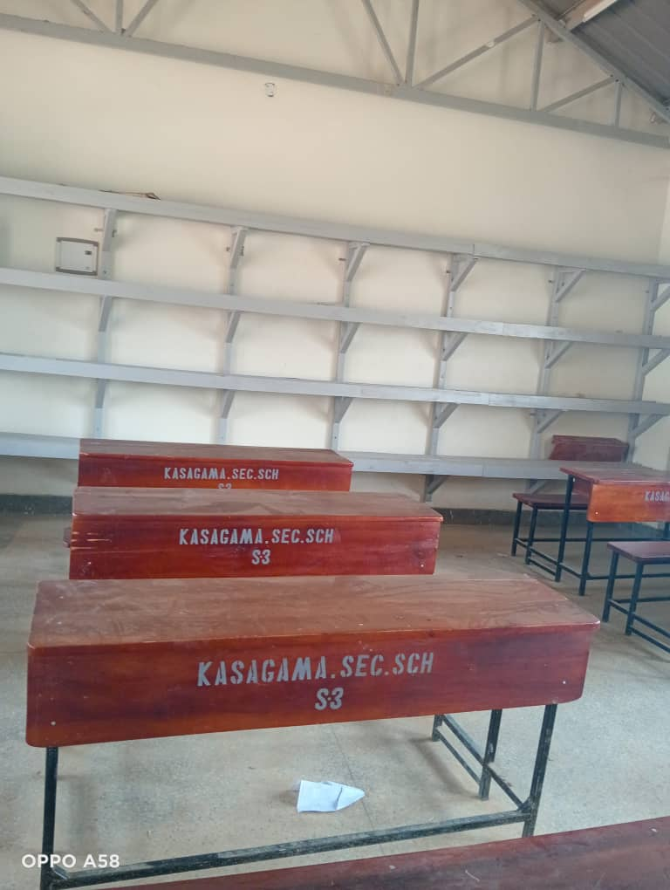
Desks Tank Chairs Table

Staff quarters
